Topic 1 – Matter and Energy
Lesson 2 – Phases of Matter

Terms to Know
Solid –

Liquid –

Gas –

Phase Change –

Exothermic –

Endothermic –

Freezing –

Melting –

Condensation –

Evaporation –

Deposition –

Sublimation –

Potential Energy –

Kinetic Energy –

Temperature –

Standard Temperature –

Solid-Liquid Equilibrium –

Liquid – Gas Equilibrium –

Absolute Zero –

Phase Changes and Energy Summary

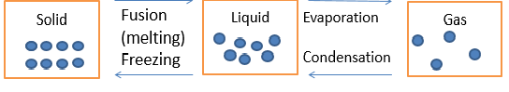

Heating Curve (Endothermic)

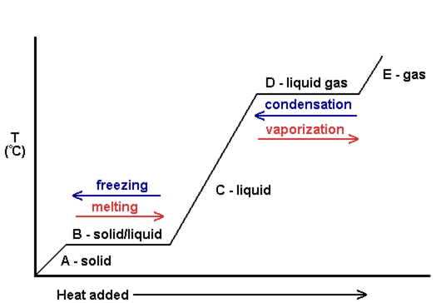

Cooling Curve (Exothermic)

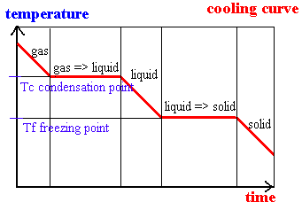

Temperature – measure of average kinetic energy of particles

10°C = lowest temperature, lowest KE

20°C = highest temperature, highest KE

As temperature increases, so does the average kinetic energy
Draw a graph showing this relationship

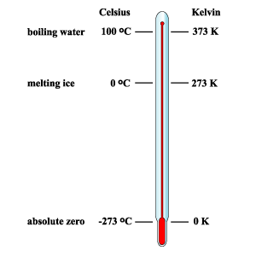

Temperature Conversion

K = °C + 273

