Topic 1 – Matter and Energy
Lesson 4 - Characteristics of gases and gas law calculations

Terms to Know
Composition of gases –

Factors that affect Gas behavior –

Volume –

Pressure –

Temperature –

Kinetic Molecular Theory –

Ideal Gases –

Real Gases –

Deviation from Ideal Gas Behavior – Effect of Molecular Mass –

Deviation from Ideal Gas Behavior – Effect of Temperature and Pressure –

Avogadro’s Law –

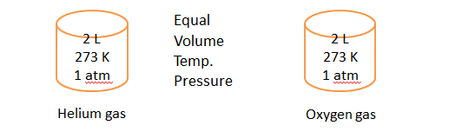

Relationship between volume and pressure at constant temperature –

Relationship between volume and temperature at constant pressure –

Relationship between pressure and temperature at constant volume –

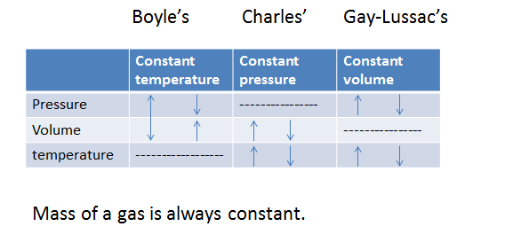Combined Gas Law –

P₁V₁ = P₂V₂
T₁ T₂

Conversion Calculations
Pressure Conversion 1 atm = 101.3 kPa
Ex. What pressure in atm is equal to 259 kPa?

259 kPa x $\frac{1 atm}{101.3 kPa}$ = 2.6 atm

Volume Conversion 1L = 1000 mL
Ex. What volume of He (g) in milliliters is equal to 1.33 L of He (g)?

1.33 L x $\frac{1000 mL}{1 L}$ = 1330 mL

Temperature Conversion K = °C + 273
Ex. What Kelvin temperature is equal to 200°C?

K = 200 + 273 = 473 K

ONLY KELVIN TEMPERATURE CAN BE USED IN GAS LAW CALCULATIONS!

Boyle’s Law
Example
At a constant temperature, what will be the new volume of a 20 L sample of oxygen gas if its pressure is changed from 2.5 atm to 5.0 atm?
Known Unknown
V₁ = 20 L V₂ = ?
P₁ = 2.5 atm
P₂ = 5.0 atm P₁V₁ = P₂V₂
(2.5)(20) = (5)V₂
V₂ = 10 L
Charles’ Law
Example
The volume of a confined gas is 25 mL at 280 K. At what temperature would the gas volume be 75 mL if the pressure is held constant?
Known Unknown
V₁ = 25 mL T₂ = ?
T₁ = 280 K
V₂ = 75 mL V₁ = V₂
T₁ T₂

25 = 75
280 T₂ T₂ = 840 K

Gay-Lussac’s Law
Example
Pressure on a gas changes from 20 kPa to 50 kPa when the temperature of the gas is changed to 30°C. If volume was held constant, calculate the initial temperature of the gas.
Known Unknown
P₁ = 20 kPa T₁ = ?
P₂ = 50 kPa
T₂ = 30 + 273 = 300 P₁ = P₂
T₁ T₂
20 = 50_
T₁ 300
T₁ = 120 K = -153°C

STP stands for Standard temperature and pressure
Standard temperature 273 K or 0°C
Standard Pressure 1 atm or 101.3 kPa

Combined Gas Law
Example
Hydrogen gas has a volume of 100 mL at STP. If temperature and pressure are changed to 0.5 atm and 546 K respectively, what will be the new volume of the gas?
Known Unknown
V₁ = 100 mL V₂ = ?
T₁ = 273 K
P₁ = 1 atm P₁V₁ = P₂V₂
T₂ = 546 K T₁ T₂
P₂ = 0.5 atm (1)(100) = (0.5)V₂
273 546
V₂ = 400 mL

