Topic 2 – Periodic Table
Lesson 1 – Arrangement of the Elements

Terms to Know
Periodic Law –

Periods –

Groups –

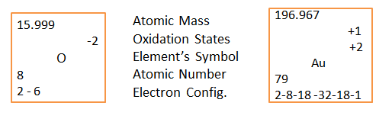
Group Names
Group 1 _____________________________________
Group 2 _____________________________________
Groups 3 – 12 _____________________________________
Group 17 _____________________________________
Group 18 _____________________________________

