Topic 2 – The Periodic Table
Lesson 3 – Group Names and Their Properties

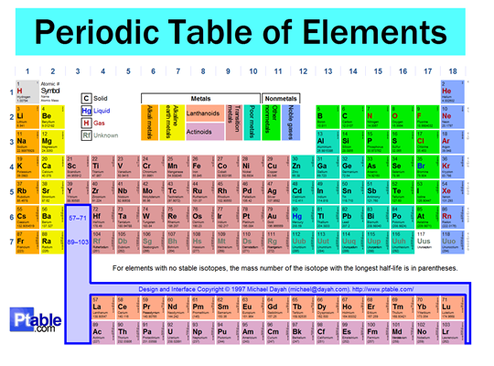

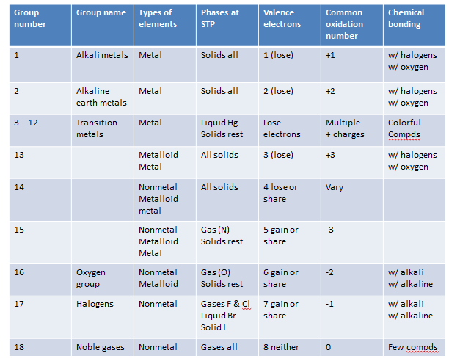

Selected Properties
Very Reactive Elements
- Group 1 Alkali Metals
- Group 2 Alkaline Earth Metals
- Fluorine

Most Reactive Metal
- Francium

Most Reactive Nonmetal
- Fluorine

Naturally Radioactive Elements
- All elements from atomic number 83 and above

Monatomic (One-atom) Elements
- Group 18 (noble gas) elements

Diatomic (Two-atom) Elements
- Fluorine
- Chlorine
- Bromine
- Iodine
- Hydrogen
- Nitrogen
- Oxygen

Element with a Double Bond
- Oxygen

Elemenet with a Triple Bond
- Nitrogen

Elements that Form Colorful Compounds
- Transition Elements (Groups 3 – 12)

Allotropes – different molecular forms of an element in the solid state
- Have different physical properties and different chemical properties and reactivity
- Oxygen allotropes – O₂, O₃ (ozone)
- Carbon allotropes – diamond, graphite, fullerine
- Phosphorus allotropes – black, red, white

