Topic 2 – The Periodic Table
Lesson 4 – Periodic Trends

Terms to Know
Atomic Radius –

Electronegativity –

Ionization Energy –

Metallic Properties –

Nonmetallic Properties –

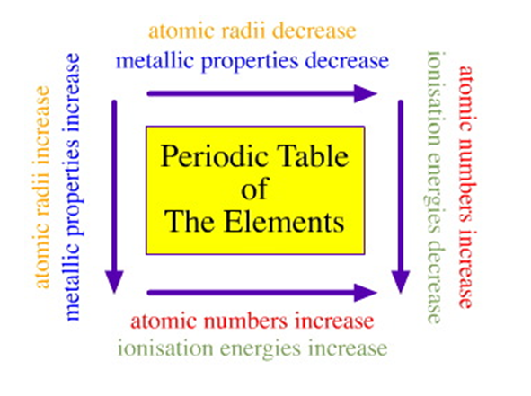

Property | Period Trend | Group Trend
Atomic Radius | Decreases due to increase in nuclear charge | Increases due to increase in number of electron shells
Electronegativity | Increases due to decreasing atomic radius | Decreases due to increasing atomic radius
Ionization Energy | Increases due to decreasing atomic radius | Decreases due to increasing atomic radius
Metallic Properties | Decrease | Increase
Nonmetallic Properties | Increase | Decrease

