Topic 3 – The Atomic Structure
Lesson 1 – The Historical Development of the Modern Atom

Terms to Know
Atom –

Hard – sphere model –

Plum – Pudding model –

Empty – Space model –

Bohr’s Planetary model –

Wave – Mechanical (Electron-Cloud) model –

Orbital –

Cathode Ray experiment –

Gold Foil experiment –

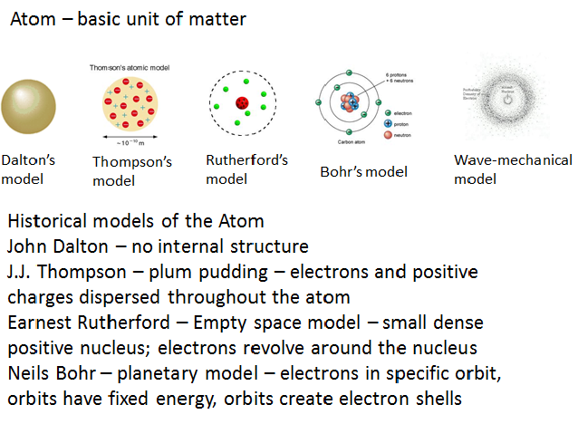
Wave mechanical model – current and most widely accepted model of the atom
- Small dense positive nucleus
- Electrons found outside the nucleus in a region called an orbital
- An orbital is an area where electrons are most likely to be found

