Topic 5 – Chemical Formulas and Equations
Lesson 4 – Chemical Equations

Terms to Know
Equation –

Nuclear Equation –

Physical Equation –

Chemical Equation –

Chemical Reaction –

Reactants –

Products –

Coefficient –

Arrow –

Synthesis –

Decomposition –

Single Replacement –

Double Replacement –

Combustion –

Law of Conservation in Reactions –

Conservation of Atoms –

Balanced Equations –

Conservation of Mass –

Equations show changes that are taking place in a substance.
There are three types of changes in Chemistry
- Chemical change – change in chemical composition of one or more substances to other substances
H₂ (g) + O₂ (g) H₂O (l)
- Physical change – change of a substance from one form (phase) to a different form without changing its chemical composition
H₂O (s) H₂O (l)
- Nuclear change – change in the nuclear contents of one atom into that of another atom
²²⁰ Fr ⁴ He + ²¹⁶ At

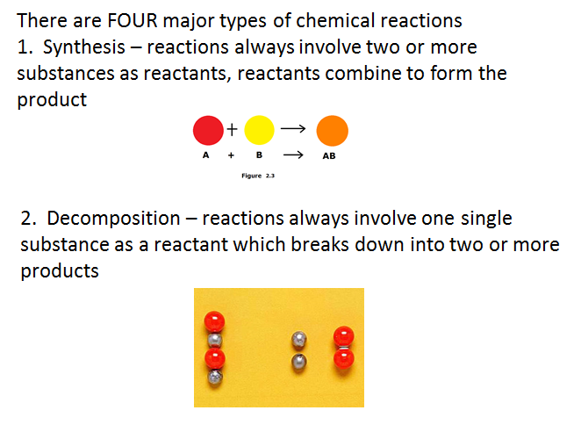
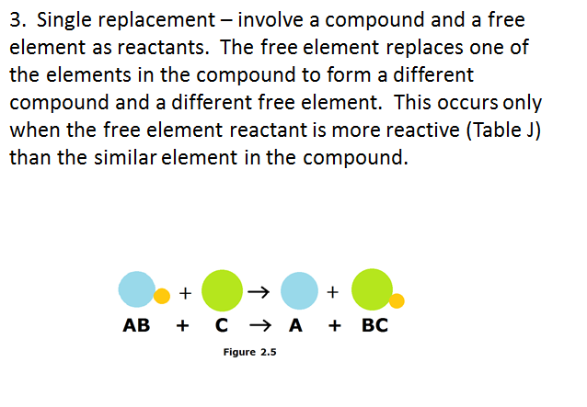

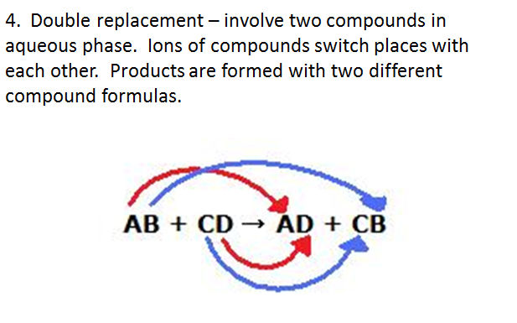
Law of conservation states that during a chemical reaction: neither atoms, mas, charge nor energy are created nor destroyed. Atoms, mass, charges, and energy are the same before and after a reaction.
A balanced chemical equation is a way of showing conservation in chemical reactions.
N₂ + 3H₂ 2NH₃
Reactants Products
N 2 N 2
H 6 H 6
A balanced chemical equation contains the correct combinations of smallest whole-number coefficients that allow number of atoms on both sides of the equation to be equal.

Strategies to balance chemical equations
- Make a table to keep track of the number of atoms as you change coefficients
- Always try to balance one atom at a time
- Every time a coefficient is changed, RECOUNT the number of each atom affected by the change. Mark the change on the table.
- Always change coefficients of free elements last.
- Be sure that coefficients are in smallest whole-number ratio.

