Topic 7 – Solutions
Lesson 3 – Descriptions of Solutions and the Solubility Curves

Terms to Know
Saturated –

Unsaturated –

Supersaturated –

Dilute –

Concentrated –

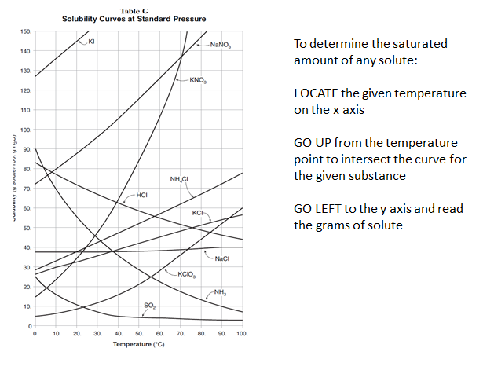

Determine the Saturated Amount
- locate the temperature in question
- go up the temperature line until you hit the curve of the substance in question
- go left to read grams of solute
- make adjustments for different amounts of water (halve amount for 50 g water; double amount for 200 g water)

Type of a Solution
- locate the temperature in question
- go up the temperature line
- stop when you have gone as high as the grams of solute in question
- solution is saturated if you stop on the curve of the substance
- solution is supersaturated if you stop above the curve
- solution is unsaturated if you stop below the curve

Difference of Solute to be added = grams to saturate at temp – grams of solute given

Grams of Solute Precipitated = saturated amount at temp – saturated amount at low temp

Substances that are most soluble, most concentrated, least dilute are closest to the top of Table G

Substances that are least soluble, least concentrated, most dilute are closest to the bottom of Table G

