Topic 7 – Solutions
Lesson 5 – Boiling and Vapor Pressure

Terms to Know
Vapor –

Vapor pressure –

Boiling point –

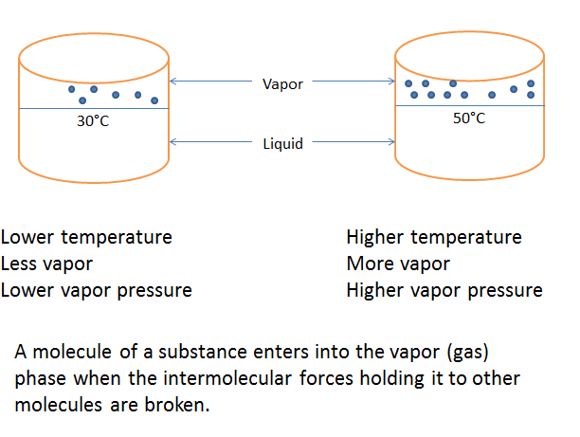
Boiling is a rapid phase change of a liquid to the vapor phase. It occurs when the vapor pressure of a liquid is equal to the atmospheric pressure.

