Topic 8 – Acids, Bases, and Salts
Lesson 2 – Reactions of Acids and Bases

Terms to Know
Acid-Metal Reactions –

Neutralization Reactions –

Titration –

Relating pH to H⁺ -

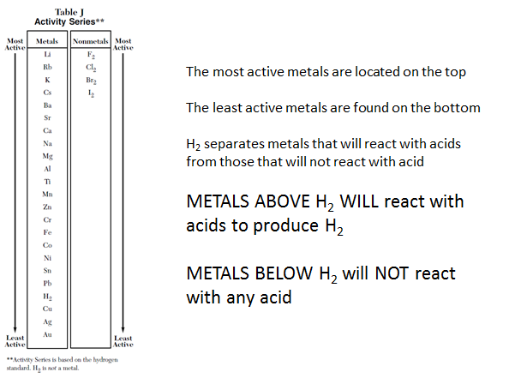

Neutralization is a reaction between an acid and a base to produce water and a salt. It is a double replacement reaction.

During neutralization reactions
- Equal moles of H⁺ and OH⁻ combine to neutralize each other and form H₂O
- Water and salt are the products of all neutralization reactions
- The salt formula formed depends on the formulas of the acid and the base

acid + base water + salt General equation
HCl + NaOH H₂O NaCl Example
H⁺ OH⁻ H₂O Net ionic equation

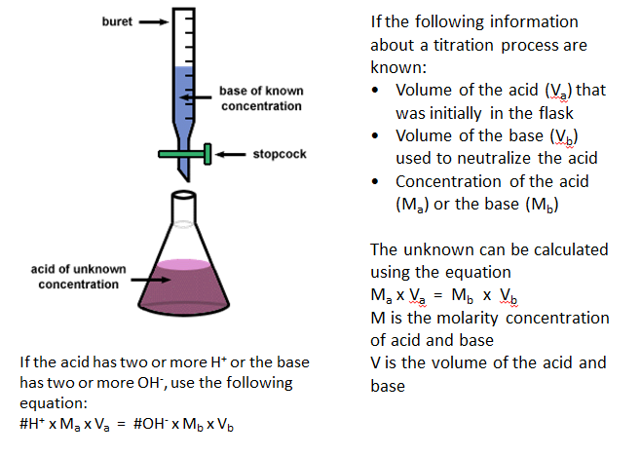

pH is defined as the – log of H⁺ ion concentration of a solution

pH is a measure of the concentration of H⁺ or H₃O⁺ in a solution

When the [H⁺] or [H₃O⁺] of a solution is given in the form of 1 x 10^{-x} M; the pH of the solution is X

Example If [H⁺] of a solution = 1 x 10⁻⁴
pH of the solution = 4

H₃O⁺ concentration pH value type of solution
1 x 10⁻² M 2 acidic
1 x 10⁻⁸ M 8 basic

