Topic 9 – Kinetics and Equilibrium
Lesson 2 – Energy and Chemical Reactions

Terms to Know
Potential Energy –

Reactants –

Products –

Activated Complex –

PE of Reactants –

PE of Products –

Heat of Reaction –

Negative Heat of Reaction –

Positive Heat of Reaction –

Exothermic Reactions –

Endothermic Reactions –

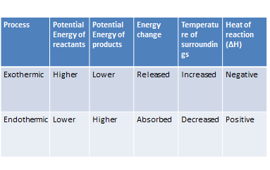

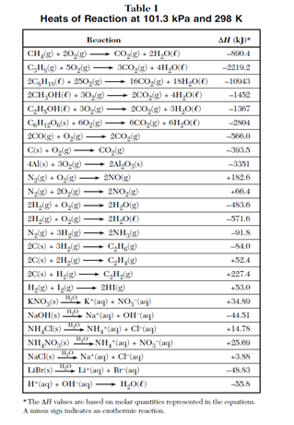

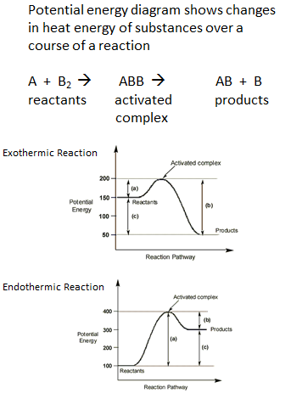

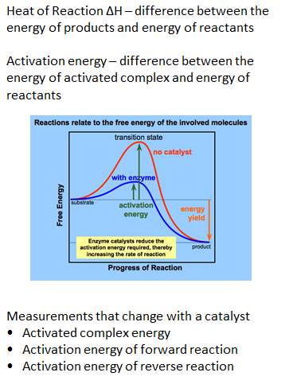
Measurements that do not change with a catalyst
- Potential energy of reactants
- Potential energy of products
● Heat of reaction

