Topic 10 – Organic Chemistry
Lesson 4 – Drawing and Naming Organic Compounds

When naming an organic structure
DETERMINE the class of organic compound from its bond type or functional group in the structure
DETERMINE the correct name prefix form the number of C atoms in the carbon chain (for ester and ether compounds, be sure to name both carbon chains)
DETERMINE the correct name ending of the compound from the class
TAKE INTO CONSIDERATION the position of a side chain, a double or triple bond, or an attached functional group when naming a given structure

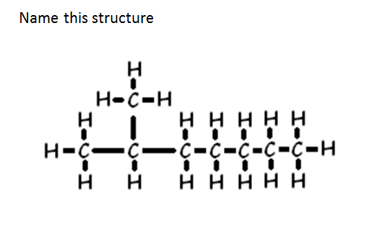
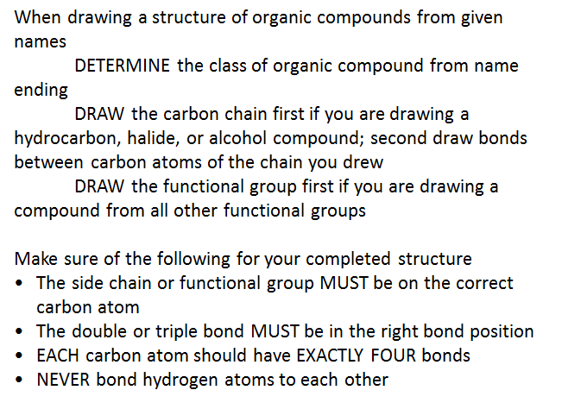
Draw the structure for heptane

Draw the structure for 2-pentene

