Topic 12 – Nuclear Chemistry
Lesson 1 – Nuclear Transmutations

Terms to Know
Nuclear Chemistry –

Nucleus –

Proton –

Neutron –

Transmutation –

Nuclear Equation –

Nuclear Change –

Chemical Change –

Physical Change –

Alpha Particle –

Beta Particle –

Positron –

Gamma Radiation –

Neutron –

Accelerator –

Penetrating Power –

Separation of Nuclear Particles –

Nuclear Stability –

Natural Transmutation –

Artificial Transmutation –

Radioisotope –

Alpha emitter –

Beta emitter –

Positron emitter –

Alpha decay –

Beta decay –

Positron emission –

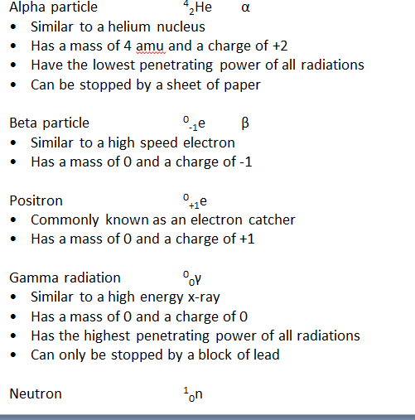

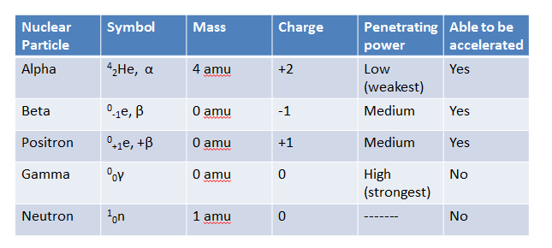

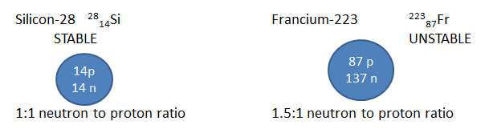

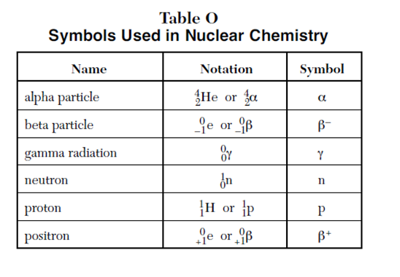
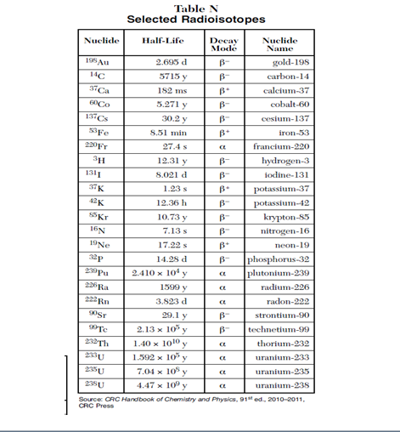

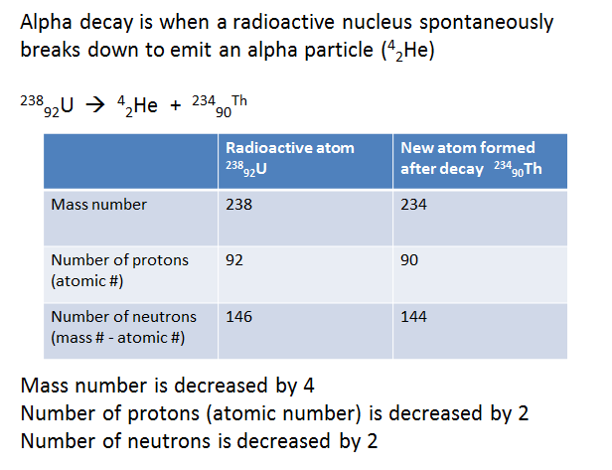
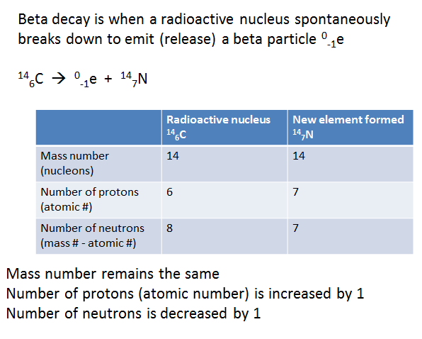
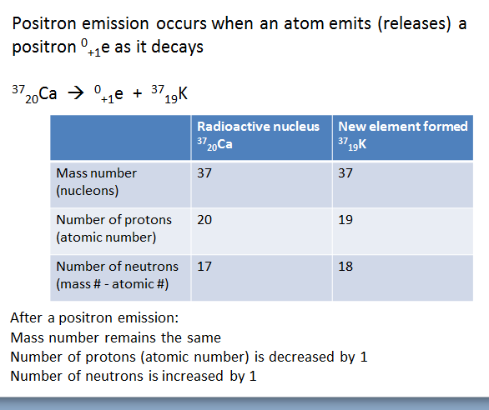

Artificial transmutation occurs when a stable non-radioactive nucleus is bombarded (hit) with a high speed particle and is changed (transmuted) into an unstable radioisotope

⁴₂He + ⁹₄Be ¹²₆C + ¹₀n

To identify artificial transmutation equations
LOOK for an equation with TWO particles on the LEFT and TWO particles on the RIGHT

