Topic 1 – Matter and Energy
Lesson 5 – Physical and Chemical Properties and Changes

Terms to Know
Physical Properties –

Extensive Properties –

Intensive Properties –

Chemical Properties –

Physical Changes –

Chemical Changes –

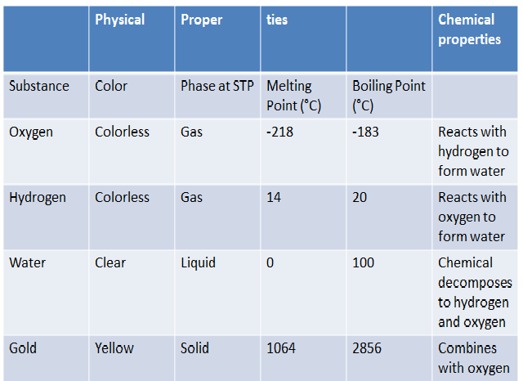

Draw an example of physical and chemical changes using particle diagrams.

