Topic 2 – The Periodic Table
Lesson 2 – Types of elements and their properties

Terms to Know
Malleable –

Ductile –

Brittle –

Luster –

Conductivity –

Electronegativity –

Ionization Energy –

Density –

Atomic Radius –

Ionic Radius –

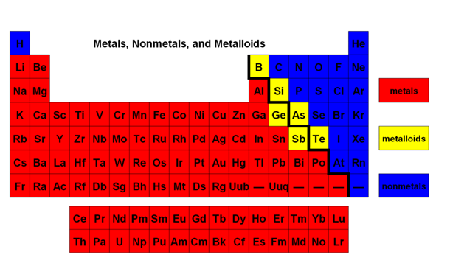

Type of Element | Phases at STP | Physical Properties | Conductivity | Electro-negativity | Ionization Energy | Electrons in Bonding | Common Ion | Ionic Radius
Metals | Solid  Liquid | Malleable  Luster  Ductile | High | Low | Low | Lose Electrons | + (positive) | Smaller than atom
Nonmetals | Solid  Liquid  Gas | Brittle  Dull | Low | High | High | Gain Electrons | -(negative) | Larger than atom
Metalloids | Solid only | Properties of Metals and Nonmetals | Low | Varies | Varies | Lose electrons | + (positive) | Smaller than atom

