Topic 4 – Chemical Bonding
Lesson 4 – Types of Substances and Their Properties

Terms to Know
Ionic Substances –

Binary Ionic Substances –

Ternary Ionic Substances –

Metallic Substances –

Network Solid Substances –

Molecular Substances –

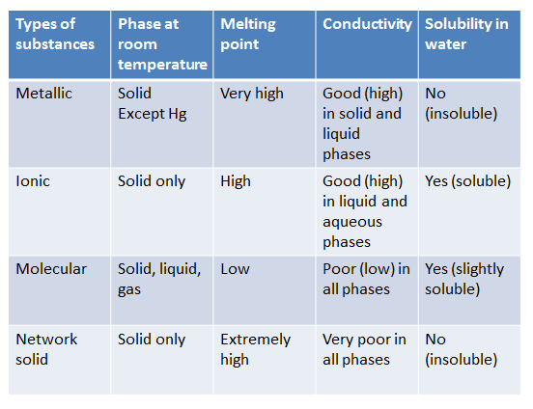

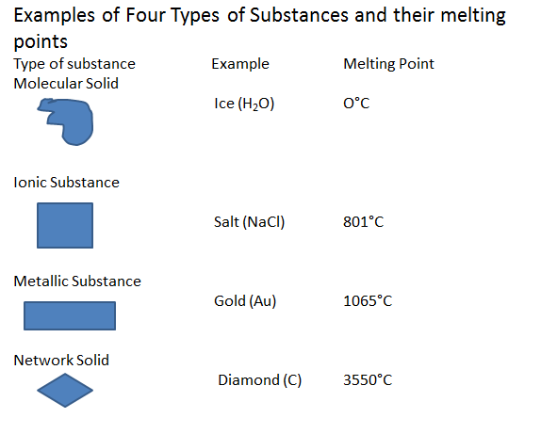
Terms (continued)
Molecule –

Polar Molecules –

Nonpolar Molecules –

Nonpolar Molecules with Nonpolar Bonds –

Nonpolar Molecules with Polar Bonds –

