Topic 4 – Chemical Bonding
Lesson 6 – Intermolecular Forces

Terms to Know
Intermolecular Forces –

Properties due to Intermolecular Forces –

Relationship between Intermolecular Forces and Properties –

Three Factors that Affect Strength of Intermolecular Forces –

Polarity and Intermolecular Forces –

Molecular Size and Intermolecular Forces –

Distance between Molecules and Intermolecular Forces –

Hydrogen Bonding –

Hydrogen Bonding and Properties –

Dipole-Dipole Attraction –

Van der Waals (London Dispersion) Forces –

Molecule-Ion Attraction –

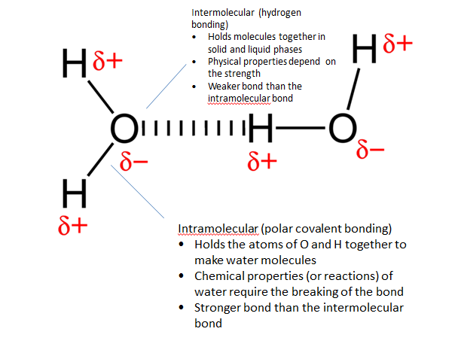

Molecule – Ion attraction in aqueous solution

