Topic 5 – Chemical Formulas and Equations
Lesson 2 – Types of Chemical Formulas

Terms to Know
Molecular Formula –

Empirical Formula –

Structural Formula –

Nomenclature –

IUPAC –

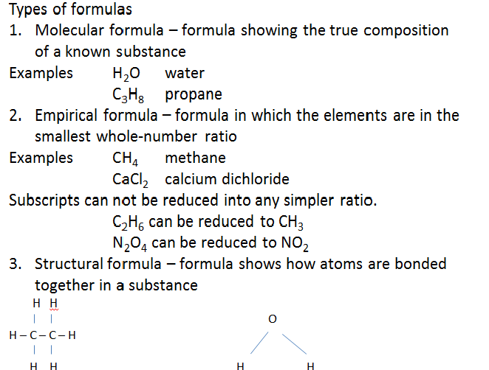

Reducing a Formula to the Empirical Formula
- Find the Greatest Common Factor (GCF) for the subscripts in the general formula
- Divide each subscript by their GCF to get the empirical formula

Write the empirical formula for NO₂, K₂S₂O₄, and C₃H₆

Given Formula NO₂ K₂S₂O₄ C₃H₆

GCF 1 2 3

Empirical Formulas NO₂ KSO₂ CH₂

