Topic 5 – Chemical Formulas and Equations
Lesson 3 – Writing and Naming Chemical Formulas

Terms to Know
Binary Compounds –

Polyatomic Ion Compounds –

Compounds with a Roman Numeral –

Binary Compounds –

Polyatomic Ion Compounds –

Compounds Containing an Atom with Multiple Oxidation Numbers –

Molecular Compounds (Naming with IUPAC Prefixes) –

Writing Chemical formulas
- Binary ionic compounds have formulas that are composed of two different elements; a metal and a nonmetal
names of binary compounds always end with –ide
Examples calcium bromide, aluminum sulfide
Step 1 Locate and write down symbols and charges of the elements using the Periodic Table.
Ca⁺² Br⁻¹ Al⁺³ S⁻²
Step 2 Criss-cross the values of the + and – charges so that each becomes the subscript for the other element
Ca₁ Br₂ Al₂ S₃
Step 3 Rewrite the formula
Ca₁Br₂ Al₂S₃
Step 4 Write the correct formula (Reduce formulas to empirical formulas, remove subscripts of 1)
CaBr₂ Al₂S₃

- Polyatomic ion compounds – contain three or more elements; may contain parentheses
Examples sodium nitrate, calcium sulfite
Step 1 Locate and write down symbols and charges using periodic table and table E; put parentheses around polyatomic ion
Na⁺¹ (NO₃)⁻¹ Ca⁺² (SO₃)⁻²
Step 2 Criss-Cross values of charges
Na₁ (NO₃)₁ Ca₂ (SO₃)₂
Step 3 Rewrite formula with subscripts but not charges
Na₁(NO₃)₁ Ca₂(SO₃)₂
Step 4 Write the correct formula (reduce subscripts to empirical formula; don’t change subscripts of polyatomic ions; remove parentheses if subscript is 1; remove subscripts of 1
NaNO₃ CaSO₃

- Most transition metals have more than one positive oxidation number. When naming compounds containing transition metals, Roman numerals in parentheses are used to indicate the oxidation number of the transition metals.
Iron (II) chloride II indicates Fe⁺²
Iron (III) oxide III indicates Fe⁺³
Lead (IV) nitrate IV indicates Pb⁺⁴

Iron (II) chloride
Fe⁺² Cl⁻¹ Fe₁ Cl₂ Fe₁Cl₂ FeCl₂

Chromium (III) sulfate
Cr⁺³ (SO₄)⁻² Cr₂ (SO₄)₃ Cr₂(SO₄)₃ Cr₂(SO₄)₃

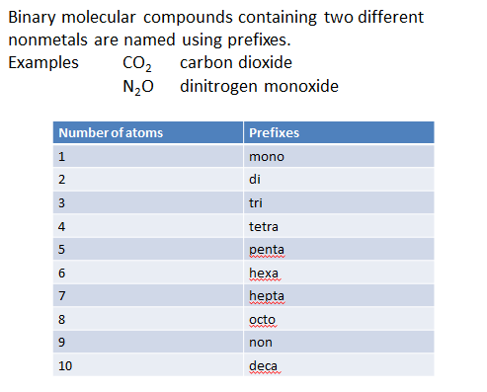

Rules for naming molecular (covalent) compounds
- The only time a prefix is NOT used is when there is ONLY ONE of the first nonmetal atom.
- The prefixes are the subscripts
- NO criss-crossing
- NO reducing t empirical formula
Phosphorus trichloride
1 phosphorus 3 chlorine
PCl₃
Dinitrogen pentoxide
2 nitrogen 5 oxygen
N₂O₅

Naming Binary ionic compounds (formula must have two different symbols – a metal and a nonmetal)
Examples ZnCl₂ CaO
Step 1 Locate and write down names of elements in the formula. Confirm that the metal has only one oxidation number.
zinc chlorine calcium oxygen
Step 2 Keep metal’s name; change the nonmetal ending to –ide.
zinc chloride calcium oxide

Naming compounds with polyatomic ions (formula must have three or more different elements)
Examples Mg₃(PO₄)₂ NH₄NO₃
Step 1 Locate and write down the names of symbols in the formula using the Periodic table and table E.
magnesium phosphate ammonium nitrate
Step 2 Write the correct name – keep the name of the metal; keep the name of polyatomic ion
(When NH₄ is combined with a nonmetal, the nonmetal ending is changed to –ide)
magnesium phosphate ammonium nitrate
No change is made to the name of the metal or polyatomic ion

Naming compounds containing transition metals
Examples CrN₂ CuSO₄
Step 1 Assign negative charge to nonmetal or polyatomic ion
Cr N₂⁻³ Cu (SO₄)⁻²
Step 2 Find the total negative in the formula (subscript x charge)
2 x -3 = -6 1 x -2 =-2
Step 3 Determine a positive number that when added to the total negative value in step 2 will have a sum of zero.
+6 +2
Step 4 Write the names of symbols in the formula, use the value of + value as Roman numeral, change nonmetal ending to –ide, keep polyatomic ion name
Chromium (VI) nitride copper (II) sulfate

Naming Binary molecular compounds (formula must contain two different nonmetals)
Examples P₂Cl₃ CF₄
Step 1 Translate formulas
2 P 3 Cl 1 C 4 F
Step 2 Name formulas (change numbers to prefixes, write the name of elements after each prefix, keep the name of the first element, change the name of the second nonmetal ending to –ide)
dinitrogen trichloride carbon tetrafluoride

