Topic 6 – Mole Interpretation : Mathematics of Formulas and Equations
Lesson 1 – Mole Interpretation in Formulas

Terms to Know
Mole –

Moles of atoms in formulas –

Molar Mass –

Gram-atomic Mass –

Gram-formula Mass –

Percent Composition –

Hydrates –

Anhydrous –

Formula Mass of a Hydrate –

Percent Composition of a Hydrate –

Formula mass = mass of 1 mole of a formula = sum of all atomic masses in a formula
To find the formula mass of a compound
Example H₂O
Step 1 Determine number of each atom 2 H
1 O
Step 2 Multiply by atomic mass 2 (1) = 2
1 (16) = 16
Step 3 Find formula mass by adding up all masses
2 + 16 = 18 g

The mass of one mole of a substance is the formula mass of that substance. One mole (6.02 x 10²³ particles) of a given substance will always weigh a mass equal to its formula mass.
To calculate the mass of any given number of moles of a substance
DETERMINE the formula mass of the substance
MULTIPLY the number of moles in question by formula mass
Moles given = mass_______ OR Mass = moles given x formula mass
formula mass

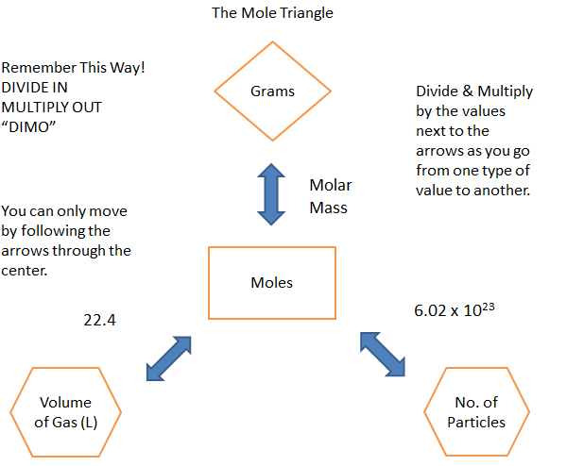

Percent Composition by Mass

% = $\frac{total mass of atom}{formula mass}$ x 100

Percent Composition by Volume
% = $\frac{part volume}{whole volume}$ x 100

Percent of Water in a Hydrate
% H₂O = $\frac{total mass of water}{formula mass of hydrate}$ x 100

Percent of Water from Hydrate Lab data
Mass of water = mass of hydrate – mass of anhydrous salt

% water = $\frac{mass of water}{mass of hydrate}$ x 100

Molecular Formula from Mass and Empirical Formula
- Determine mass of the empirical formula
- Determine how many units of the empirical formula
- Determine the molecular formula by multiplying each subscript of the empirical formula by the unit

Number of Particles Calculation
1 mole = 6.02 x 10²³

Volume of a Gas Calculation
1 mole of a gas = 22.4 L

