Topic 9 – Kinetics and Equilibrium
Lesson 4 – Equilibrium

Terms to Know
Equilibrium –

Physical Equilibrium –

Phase Equilibrium –

Solution Equilibrium –

Chemical Equilibrium –

Stress –

LeChatelier’s Principle –

Common Ion Effect –

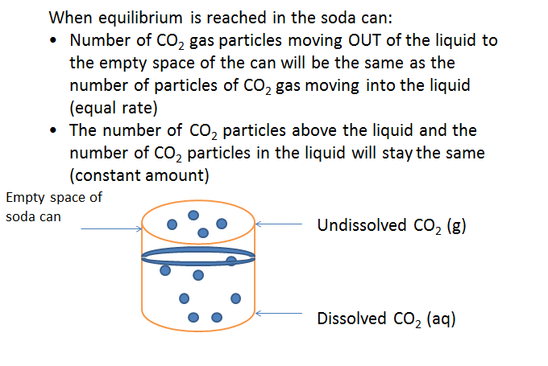

LeChatelier’s Principle states that when a stress is introduced into a reaction at equilibrium, the reaction will change by speeding up in one direction and slowing down in the other direction to bring the reaction back to equilibrium

STRESS 1: Increasing concentration
When a substance is added to a reaction to increase its concentration
- Rate increases toward opposite side of the change
- Rate decreases toward the same side of the substance
- Concentration of other substances on the same side of the change decreases
- Concentration of all substances on the opposite side of the change increases
- Reaction will shift (speeds up) toward the opposite side of the change
FORWARD
N₂ + 3H₂ < ------- > 2NH₃
Add stress: Increase concentration of N₂
RESULT
- Rate of forward increases
- Rate of reverse decreases
- Concentration of H₂ decreases
- Concentration of NH₃ increases
- Shift of reaction is to the RIGHT

STRESS 2: Decreasing concentration
- Rate increases toward the side of the change
- Rate decreases toward the opposite side of the change
- Concentration of other substances on the side of the change increases
- Concentration of all substances on the opposite side of the change decreases
- Reaction will shift (speeds up) toward the side of the change
X + WY < -------- > XY + W
REVERSE
Add stress: Decrease concentration of WY
RESULT of decreasing concentration of WY
- Rate of forward reaction decreases
- Rate of reverse reaction increases
- Concentration of XY and W decreases
- Concentrations of X increases
- Shift in reaction is to the LEFT

STRESS 1: Increasing temperature (adding heat)
- Favors endothermic reaction
- Rate increases toward the side without the heat (endothermic reaction increases)
- Rate decreases toward the side with the heat(exothermic reaction decreases)
- Concentration of substances on the side with the heat decreases
- Concentration of all substances on the side without heat increases
- Reaction will shift (speeds up) toward side without heat

HI + heat < ------------ > H₂ + I₂
Add stress: Increase heat (temperature)
RESULT of increasing heat
- Rate of forward reaction increases
- Rate of reverse reaction decreases
- Concentration of HI decreases
- Concentration of H₂ and I₂ increases
- Shift of reaction to the RIGHT

STRESS 2: Decreasing Temperature (Removing heat)
- Favors exothermic reaction (removing heat causes the exothermic reaction to increase)
- Rate increases toward the side with the heat (exothermic reaction increases)
- Rate decreases toward the side without the heat (endothermic reaction increases)
- Concentration of substances n the side with the Heat increases
- Concentration of all substances on the side without Heat decreases
- Reaction will shift (speeds up) toward the side with heat
H₂ + I₂ < -------- > HI + heat
Add stress: Removing heat
RESULT of removing heat:
- Rate of forward reaction increases
- Rate of reverse reaction decreases
- Concentration of HI increases
- Concentration of H₂ and I₂ decreases
- Shift of reaction toward the RIGHT

Stress 1: Increasing pressure (decreasing volume in gaseous reaction)
- Rate increases toward the side of the smaller number of moles
- Rate decreases toward the side of the greater number of moles
- Concentration of substances on the side of smaller number of moles increases
- Concentration of substances on the side of greater number of moles decreases
- Reaction will shift (speeds up) in the direction of the smaller number of moles
- None of the above will change if the number of moles on both sides are equal
CH₄ + H₂O < ----------- > 3H₂ + CO
Add stress: Increase in pressure
RESULT of increasing pressure
- Rate of reverse reaction increases (favors production of substances on side with lesser number of moles
- Rate of forward reaction decreases
- Concentration of CH₄ and H₂O increases
- Concentration of H₂ and CO decreases
- Shift of reaction to the LEFT

Stress 1: Increasing concentration by common ion effect
- Rate increases toward the opposite side of added ion (toward the solid)
- Rate decrease toward the same side as the added ion (toward aq)
- Concentration of other substances n the side of the added ion decreases
- Concentration of substances on the opposite side of the added ion increases
- Reaction will shift toward the opposite side of the added ion (toward the solid)

KNO₃ (s) < ------- > K⁺ (aq) + NO₃⁻ (aq)

Add stress: Adding KCl (s): Will dissolve to give more K⁺
K⁺ concentration will increase
Result of adding KCl
- Rate of reverse reaction increases
- Rate of forward reaction decreases
- Concentration of NO₃⁻ decreases
- Concentration of KNO₃ (s) increases
- Shift of the reaction is to the left

